**(SECJ1013) PROGRAMMING TECHNIQUE 1**

**SEM 1, SESSION 2023/2024**

**LAB EXERCISE 1**

**INSTRUCTIONS TO THE STUDENTS**

* This exercise must be done **individually**.
* Any form of plagiarism is **NOT ALLOWED**. Students who copied other students' assignments will get **ZERO** marks (both parties, students who copied, and students who shared their work).
* Please insert your **name and matric number** as a comment in your solution.

**SUBMISSION PROCEDURE**

* Please submit this exercise no later than **October 22, 2023, Sunday (17:00 MYT)**.
* Only one file is required for the submission (the file with the extension **.pdf**).
* Submit the assignment via the UTM's e-learning system (<https://elearning.utm.my/23241/>).
* Note: Draw your flowchart using any appropriate drawing tools such as Microsoft Visio, Lucid chart (<https://www.lucidchart.com/pages/examples/flowchart-maker>), and draw.io (<https://app.diagrams.net/>).

# SET 1

Construct a flowchart based on the pseudocode below.

***Hint****: The* ***bold fonts*** *show the keywords that need to be included in the flowchart.*

|  |
| --- |
| 1. **Start** 2. **Data Collection** is to collect data 3. **Data Cleaning** is to prepare the collected data 4. If it **has a target** from the data   4.1 Yes, go to **Feature Extraction**  4.2 No, go to Data Collection   1. Feature Extraction is used to extract the specific data used for prediction 2. **Feature Classification** is to classify the data used to predict performance 3. **Split Data** is to split data into 80% training datasets and 20% test datasets   7.1 **Train Dataset with 20%**  7.2 **Test Dataset with 80%**   1. **Machine Learning Process** is used for creating a model of machine learning algorithms 2. **Prediction Model** is to create a model for certain purposes 3. Evaluation Model (e.g., **Grade Point Average**) is to evaluate the predicted model 4. During **Measure Accuracy**, if Accuracy is high   11.1 Yes, go to Display result **Accuracy Prediction**  11.2 No, go to Feature Extraction   1. **End** |

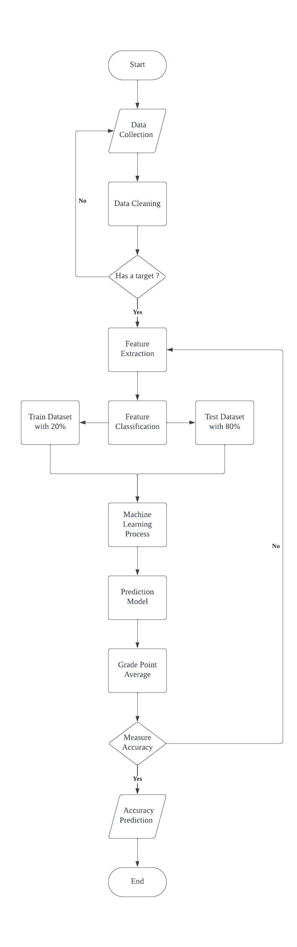

# SET 2

Construct a pseudocode based on the case study below.

PT1 Hotel offers two rental packages to customers. The following is the rental cost for each package:

Package Rental Price per Night (RM)

Weekday 150

Weekend/ Public Holiday 250

Customers must pay a deposit of 10% of the rental cost before placing an order. Customers who are regular customers receive a 10% discount. Complete the following pseudocode, which prompts users to enter their name, length of stay, package (1 - Weekday, 2 - Weekend/ Public Holiday), and customer type (Regular or Normal). The pseudocode should calculate and display the customer's name, deposit payment, total discount given (if any), and the remaining rental cost to be paid.

1. Start

2. deposit = 0.10

3. Get the name, duration, package, customer_Type

4. If package == 1

4.1 price = 150

5. else

5.1 price = 250

6. End If

7. If customer_Type == Regular

7.1 discount = 0.10

8. else

8.1 discount = 0.00

9. End If

10. price = rental * duration

11. deposit_Payment = deposit * price

12. total_Discount = discount * price

13. balance = price - deposit_Payment – total_Discount

14. Display name, deposit_Payment, total_Discount, balance

15. End

# SET 3

Construct a pseudocode that reads an integer number and then calculates the product of its digits. After that, identify whether the product of digits for the integer is a multiple of 4, 5, and/ or 7. ***Hint:*** You should use the operator divide (/) and modulus (%) and also **pre-test loop** to answer this question.

***Example 1 Example 2***

Enter an integer number: **9212** Enter an integer number: **61145**

9 * 2 * 1 * 2 = 36 6 * 1 * 1 * 4 * 5 = 120

36 is a multiple of 4 120 is a multiple of 4 and 5

***Note:*** The number in **bold** shows input entered by the user.

1. START

2. Get num , result = 1

3. while num != 0

3.1 digit = num %10

3.2 result = result * digit

3.3 num = num/10

4. end while

5. display result

6. If (result % 4==0)

6.1 set multiple_4 = 4

7. end if

8. If ( result % 5 == 0)

8.1 set multiple_5 = 5

9. end if

10. If (result % 7 == 0)

10.1 set multiple_7 = 7

11. total = multiple_4 + multiple_5 + multiple_7

12.If (total == 4)

12.1 display result is a multiple of 4

13. else if ( total == 5 )

13.1 display result is a multiple of 5

14. else if ( total == 7)

14.1 display result is a multiple of 7

15. else if ( total == 9)

15.1 display result is a multiple of 4 and 5

16. else if ( total == 11)

16.1 display result is a multiple of 4 and 7

17. else if (total == 12)

17.1 display result is a multiple of 5 and 7

18. else if ( total == 16)

18.1 display result is a multiple of 4 , 5 and 7

19. else

19.1 display result is not a multiple od 4,5 and 7

20. end if

21. END

# SET 4

Construct a flowchart that reads an integer number and then calculates the product of its digits. After that, identify whether the product of digits for the integer is an even or odd number, and a multiple of 3, and/ or 5. ***Hint:*** You should use the operator divide (/) and modulus (%) and also the **post-test loop** to answer this question.

***Example 1 Example 2***

Enter integer number: **256** Enter integer number: **7442**

2 * 5 * 6 = 60 7 * 4 * 4 * 2 = 224

60 is an even number and multiples of 3 and 5 224 is an even number

***Note:*** The number in **bold** shows input entered by the user.

1. START

2. Get num , result = 1

3. while num != 0

3.1 digit = num %10

3.2 result = result * digit

3.3 num = num/10

4. end while

5. display result

6. If (result %2==0)

6.1 If (result%3==0)

6.1.1 display result is an even number and multiples of 3

6.2 else if (result%5==0)

6.2.1 display result is an even number and multiples of 5

6.3 else if ((result%3==0)&&(result%5==0)

6.3.1 display result is an even number and multiples of 3 and 5

6.4 else

6.4.1 display result is an even number

6.5 end if

7. else

7.1 If (result%3==0)

7.1.1 display result is an odd number and multiples of 3

7.2 else if (result%5==0)

7.2.1 display result is an odd number and multiples of 5

7.3 else if ((result%3==0)&&(result%5==0)

7.3.1 display result is an od number and multiples of 3 and 5

7.4 else

7.4.1 display result is an odd number

7.5 end if

8.end if

9. END

